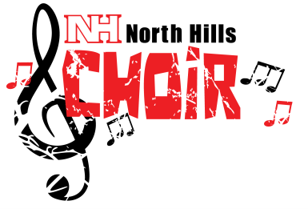
7th & 8th Grade Choirs
Important information!

MANDATORY COMBINED REHEARSALS

7th Grade: Monday, December 16, Homeroom until 4pm

8th Grade: Tuesday December 17, Homeroom until 4pm

Concert Choir: Tuesday December 17, after school until 5pm

MANDATORY CONCERT

6:30pm – Report time - Do NOT be late!
7:00pm – Performance in North Hills Middle School Auditorium (Parents and families encouraged to attend!)

DRESS CODE for CONCERT

Girls
Black skirt (at least knee length)
White shirt/blouse
Black shoes (flat or low heel)

The Concert and all rehearsals are mandatory for each student or member. Illness, death in the family, or out of town trips would be considered excused absences. If any of these occur, a parent should call Mrs. Triscila or send a written note prior to the concert. I appreciate your cooperation and look forward to you hearing your children sing! If you have questions or concerns, please contact me!

Mrs. Triscila triscilar@nhsd.net 412-318-1000 ext. 4561
Boys
Black dress pants/slacks
White long-sleeve dress shirt
Tie
Black shoes (black socks)

