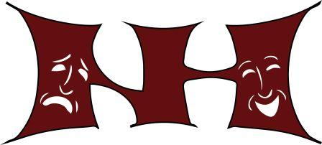NORTH HILLS DRAMA CLUB

Dear Parents and Members of Cast, Crew and Orchestra for Dames at Sea,

One of the Drama Club’s fundraisers each year is the lobby basket raffle. This occurs during each performance of the Fall Play and Spring Musical.

As one of the items to raffle off this year during the musical, we are asking each member of the cast, crew, and orchestra to send in a scratch off lottery ticket(s) to be a part of a lottery tree that we will raffle off. Please bring in your ticket in an envelope marked “Lottery Tree” and give to either director.

Proceeds from the basket raffle go towards the many expenses that go into the Fall Play and Spring Musical such as costumes, props, and scenery. Your participation in this fundraiser is greatly appreciated. If you have any questions, please contact me at dh.margo@verizon.net .

Sincerely,

Heather Margo

