Villagers -
Girls: long dresses, Long skirts, blouses, vests, aprons, hats, character shoes (wear neutral colors and dull colors- no bright or neon colors)

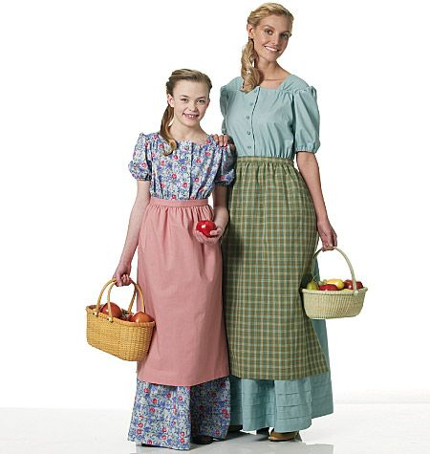

Character Shoes

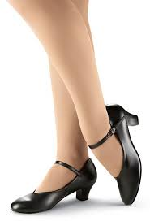

Villagers:

Boys: Khaki , brown or black pants, button up collared shirts, vests, jackets, neck tie or bow tie, dress shoes or boots- (wear neutral colors and dull colors- no bright or neon colors)

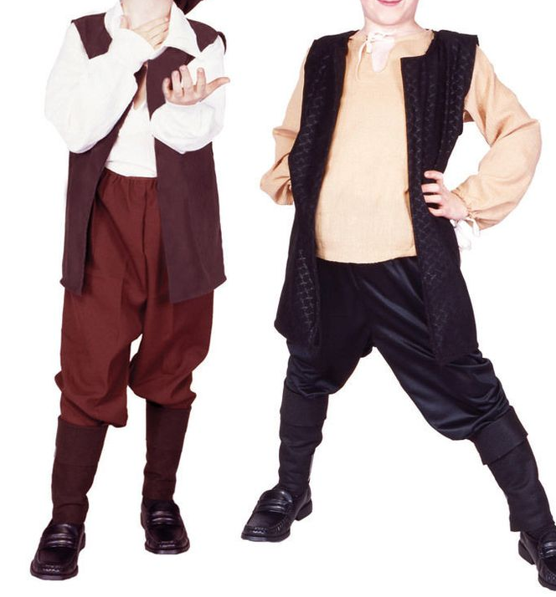
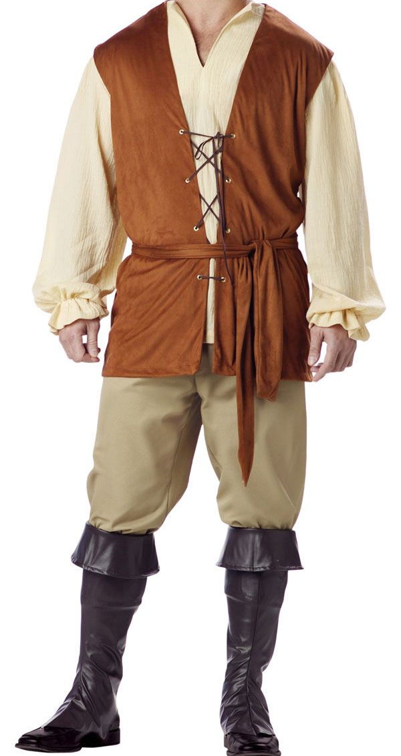

The Beast (Sean):
Black pants, a white button up dress shirt with a collar, black shoes, black socks, white undershirt (tanktop or tee shirt)
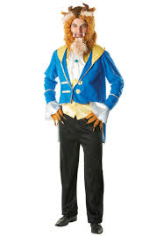

Belle (Jane)- Wigs, blue bow for hair, beige character shoes, beige leotard (to wear under costumes), wig cap

Gaston (Aiden)- Black or brown boots, black dress pants, dress socks to wear with boots

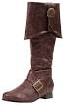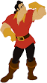

Maurice (Koby)– Brown pants that are baggy- (that can be altered/shortened), long black or brown socks (not athletic socks), black or brown shoes

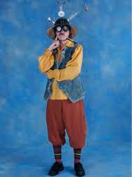

LeFou- (Zach) White collared- button up dress shirt, brown or black dress shoes, long black/brown socks (not athletic socks)

Lumiere (Grant)- White collared, button up, dress shirt, Black dress shoes, long black socks (not athletic socks)

Cogsworth (Tyler)- black button up/long sleeve collared shirt, black dress pants, black long socks and black dress shoes
Colored bow tie to wear with black pants and shirt for human costume

Silly Girls (Kelly, Juliet, Hannah)- character shoes, bow for hair to match your dress color
If you can- coordinate what type of bow you are getting with each other so they match

Babette- (Juliana)- Black character shoes, tan leotard for underneath dresses

Madame – (Julia) -Character shoes (not sure about what needs to go under costume yet- I’ll let you know asap about clothing you need)

Mrs. Potts- (Eleanore) – Black or beige character shoes (I’ll let you know asap about clothing you need)

Chip- (Grace) (you will be in a cart then human) For human costume – find boys pants- brown or khaki, long sleeve button up dress shirt, little boots or dress shoes (that don’t look like girls shoes) A little hat to go with costume would be great! Wear a vest or jacket over dress shirt. See me Monday- I might have something for you to try on.
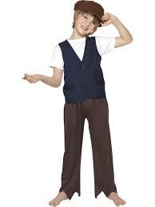

Monsieur D’arque & Book Seller (Olav)-
For book seller- dress as a villager
Monsieur D’arque – white button up dressshirt, black dress pants, black dress shoes, black dress socks

Enchantress (Kersten)-also villager- Black Character shoes, In addition to your enchantress dress, dress as a villager

Aristocratic Lady- (Darby)- black or beige Character shoes

Hat Seller-Emerson S.- Dress as a villager

Candle Man- Narrator # 4- Max B. – Dress as a villager

Milk Maid- Narrator # 1- Katie S.- Dress as a villager, wear an apron and bonnet/white bandana, if you can find a small metal pail / bucket please bring that

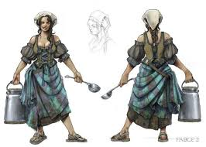

Candle Man- Narrator # 2- Grant M. – dress as a villager

Lady with cane- Abby Begler- Dress as a villager, if possible bring wooden cane

Lady with Baby- Narrator number 3- Marissa- Dress as a villager- bring infant baby doll and blanket to carry- (if you can’t find one don’t buy one let me know)

Shepard boy- Josh K.- Dress as a villager

Fish Man- Charlie K.- Dress like a villager, ---black, brown or khaki pants, wear a vest with shirt underneath

Baker- Byron S.- White button up shirt (long or short sleeve), black dress pants, black shoes, black dress socks

Egg man- Stephen R.- Dress like a villager

Butcher-Ben S.- brown, black or khaki pants, white button up dress shirt, black shoes with black sock- long socks not athletic

Sausage curl girl-Emma Craft- Dress like villager (dress)- SEE ME before you buy something- I have a dress I want you to try on

** Featured dancers you will also need to have villager costumes- see villager page

Wolves- long sleeve black shirt (or leotard), black leggings… character or Jazz shoes

Plates- White leggings, white long sleeve shirt (cotton or jersey material – not a blouse/dress shirt)
Beige character shoes

Salt and Pepper-(Julia & Ellie)- Black character shoes, black long sleeve shirt or leotard, black leggings

Spoons, knives, forks, whisk, and Cheese grater- Black character shoes, black long sleeve shirt or leotard, black leggings

Napkins- Long Sleeve White shirt (or leotard), white leggings… character or Jazz shoes

** All Black or white leggings should be fitted, not baggy sweat pants, the shirts they should be fitted not a large/baggy tee shirt- should be long enough that stomach would not be showing

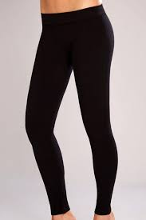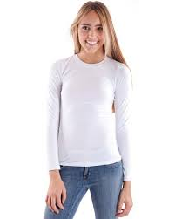
Character Shoes

